Chapter 17, Solution 7.

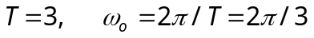
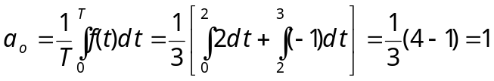

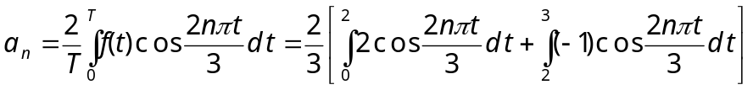

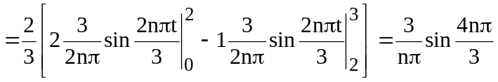

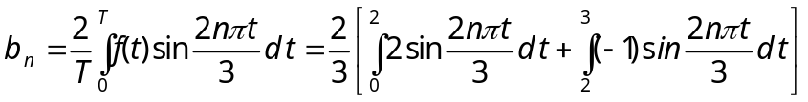
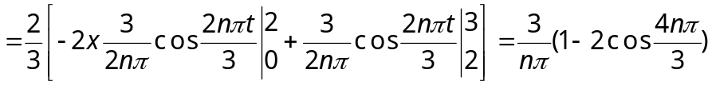
=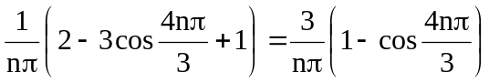

Hence,
f(t) = 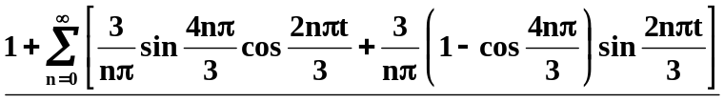

We can now use MATLAB to check our answer,

>> t=0:.01:3;
>> f=1*ones(size(t));
>> for n=1:1:99,
f=f+(3/(n*pi))*sin(4*n*pi/3)*cos(2*n*pi*t/3)+(3/(n*pi))*(1-cos(4*n*pi/3))*sin(2*n*pi*t/3);
end
>> plot(t,f)

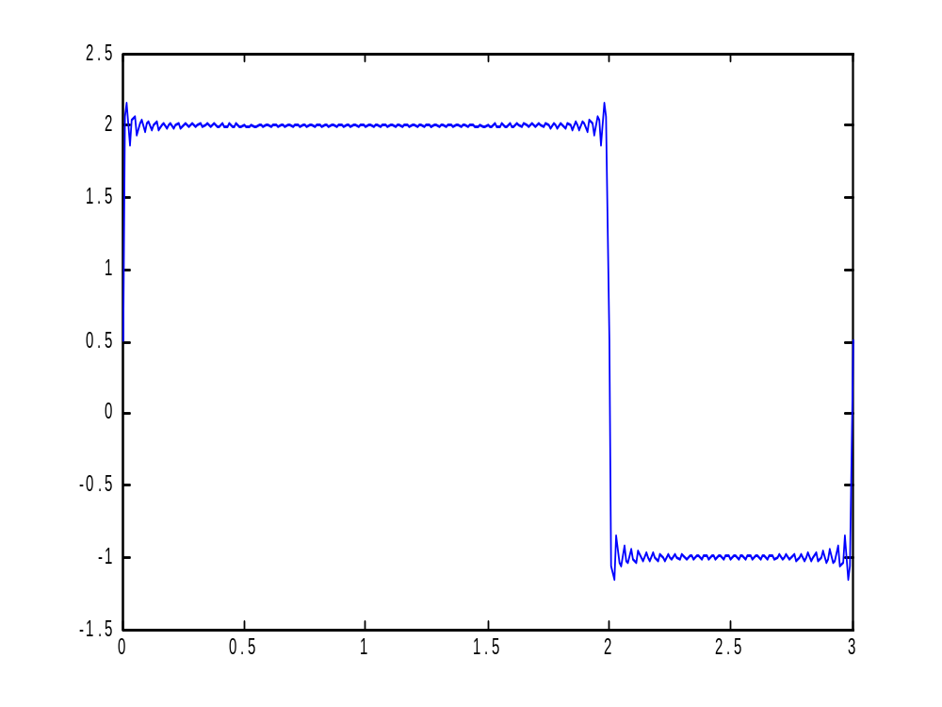

Clearly we have nearly the same figure we started with!!

